# NIMT Change Requests

## Background

Changes described below are required in order to:

* Simplify the Submission Tab in Change Request
* Provide correct information in the submission tab – including the phasing
* Avoid updates of the submission tab from Cost Sheet during the life of the change request
* Allow correct translation to CHF (company currency) and thus correct approval process

It is noted that at this moment the standard application does not bring expired and completed elements into the change. It something that is wrong in principle and should be fixed in the future.

Attached Excel sheet makes necessary part of this specification and contains a concrete example with formulas.



## Submission tab in local currency

At creation the submission tab shows values in local currency that are aligned with the values in the Cost Sheet:

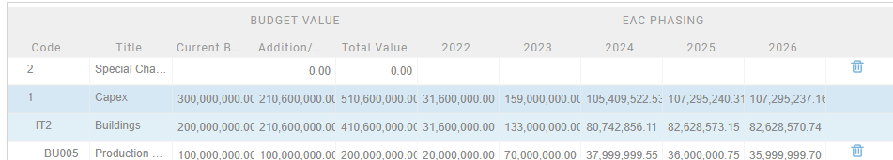

Change the name of the columns as follows. Is it possible to wrap the text to avoid that text is not visible?

* + Code
  + Title
* Total Value
  + Current Budget – as per cost sheet
  + Addition / Reduction – Difference between Total Value and
  + Total New Value *(in bold)* - value to be approved. EAC value for elements included in the change. Current budget value for elements excluded from the the change
* Phasing
  + Relevant years – EAC phasing as per cost sheet for included elements. Current Budget phasing

If possible we can also increase the hight of the table as there is enough space on the page and we could limit the scrolling

Developer Comments –   
1- Will change the column name as defined above. Also values for the total column and phaing need to be change as define formula.

2 – We will increase the height of the control

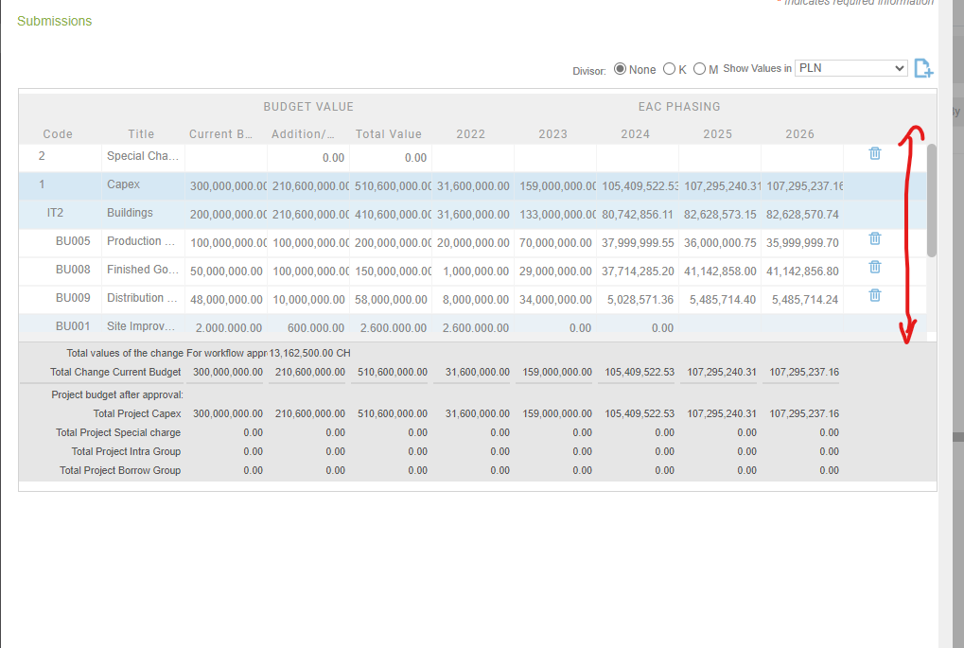

Below the detailed list of the elements there is a summary table showing total figures of the lines above per Level 1 (for the new cost sheet version) or per cost type (in the old cost sheet version):

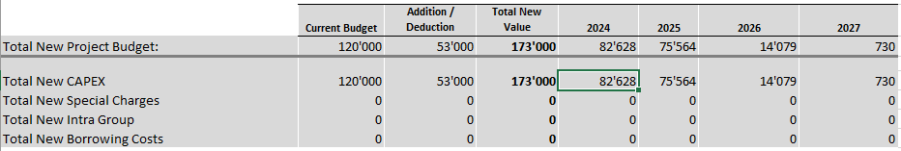

Total New Project Budget: is sum of the lines below

Total New Capex – Total of elements #1 (or Cost Type CAPEX)

Total New Special Charges – Total of elements #2 (or elements cost type OPEX)

Total New IntraGroup – Total of elements #3 (or elements costs type IntraGroup)

Total New Borrowing Costs – Total of elements #4 (did not exist in old cost structure)

It will be beneficial to repeat the column header from the table above.  
  
  
Developer Comments –   
1- New row need to be added (Total New Project Budget: is sum of the lines below

) and row (Total Change current budget) need to be remove.

2 – Rest all four row already added.

In the workflows parameters we use the Value of the Change that is different (in CHF) from the value displayed in the “addition/deduction” column. The reason is that the addition/deduction includes an exchange rate evolution impact. Also we want to assess the total of all change requests to avoid that many small changes are submitted to avoid higher level of approval. It is not always obvious to the user and therefore we want to display the value that is used to assess the necessary approvers for the change.

At the bottom of the page we will show the following text with updated figure in CHF:



Do not use any columns as the text must be visible as a whole. The value is calculated as follows: (“Total New Value (as per above) in LC” minus “Original Budget” in LC) * current year budget exchange rate.  
  
Developer Comments –   
1- New Worklow parameter need to be added (“Total New Value (as per above) in LC” minus “Original Budget” in LC) * current year budget)

2 – We will add the footer to show the below text   


## Submission tab in CHF (company currency)

The values in CHF must follow exactly the same rules as the values in Local Currency. Current budget value is the same as current budget value in CHF in cost sheet (based on phased exchange rate translation). New Total Value equals EAC for included elements and Current Budget for excluded elements. Phased (Year) values equal EAC for included elements and Current Budget for excluded elements.

Addition/Reduction = Total New Value in CHF - Current budget in CHF. There is no direct translation of the Addition /Reduction from the LC value.

Developer Comments –   
1- Current Budget and Addition/Reduction column is working fine.

2 – New Total Value column need to be change as per the new formula (EAC for included elements and Current Budget for excluded elements)

3 - Phased (Year) columns also need to be change as per the new formula (EAC for included elements and Current Budget for excluded elements)

## Changes to submission tab in the life of the workflow

The exchange rates are being updated every month and therefore also the values of credits in CHF are changing every month even if the values in LC would not change. The values in the submission tab of the change request in CHF should be updated when the CHF values in cost sheet are updated when the change request is in the step 1 of the workflow. As soon as the Workflow moves to Step 2, the values should be frozen. (can be discussed if this complexifies the development).  
  
Developer Comments –   
1- This snapshot functionality is working fine. As we have implemented few month back.

## Export to excel of the change request

The issue with the current format of the form is that the “cost sheet” part has only limited number of lines and therefore it is useless.

It would be best if this section contains only the summary line of 0 – total project, 1-CAPEX, 2- Special Charges, 3- Intragropup, 4-Borrowing.

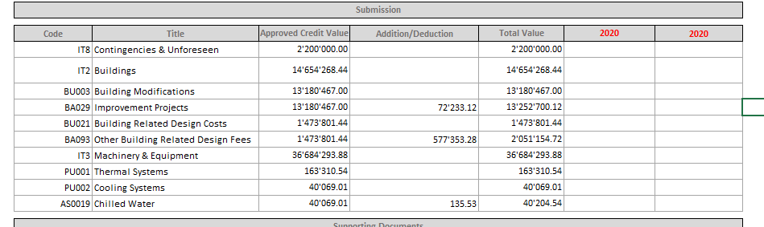

On top of that, the current version does not sum up the higher nodes and therefore the numbers are wrong.

It will be useful if the tab with the detailed “cost sheet” is not hidden as default. That tab can be useful and is the only way to get those the data into excel.

  
  
Developer Comments –   
1- This need to be change as a whole.

## List of change request

Review the CHF values in the header of the change request list as they do not seem to correspond to any number in the respective credit:

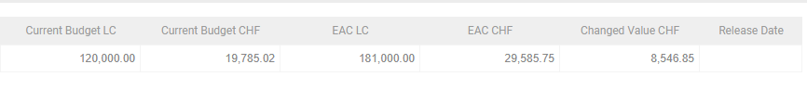

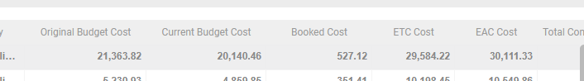

Developer Comments –   
1- Current budget and EAC will be same for all the approve change request. And change value will be available for all the not approved change request.